Oratilwe Kobe (ST10528284)
WEDE5020 POE PART 1 PROPOSAL
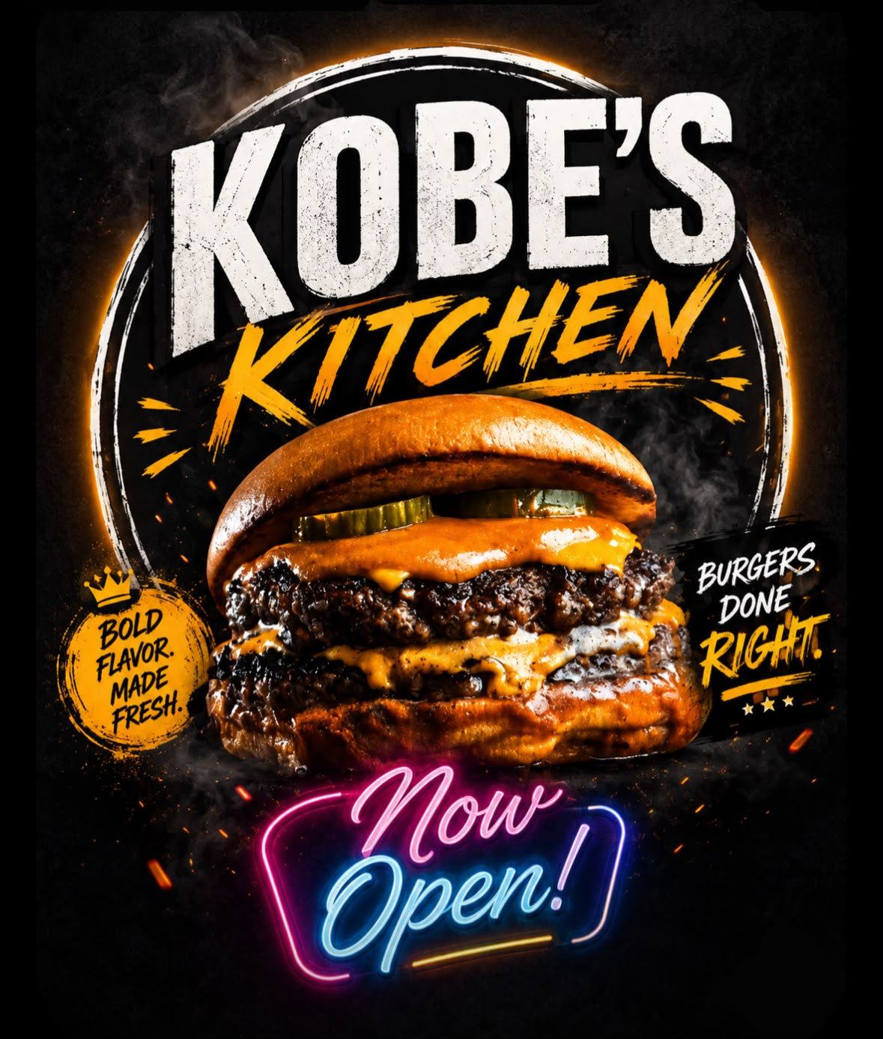

Proposal Content
- Organization Overview
Name:
Kobe’s Kitchen
History:
Kobe’s Kitchen is a family business that started in the year 2026 in Clayville (Olifantsfontein), Gauteng. When a small family of five came up with a raw idea to buy a fast food mini-truck. The mother in the family has always had love for cooking, she was a great cook. So they took it upon themselves to go through this journey of selling Kasi's flavorful foods to their community and people around the world.
Mission:
To serve fresh, flavorful Kasi food that will bring people together. We cook our food with love, and we also strive to make every meal feel like home.
Vision:
To be the most loved local food brand in the community and to be known as one of the best food sellers in the community. To have multiple Kobe’s Kitchens in different communities. Lastly, to become the go-to spot for multiple food lovers
Target Audience:
Anyone since it’s a family business that sells food to different communities, but we don’t sell food to kids under the age of 10.

- Website Goals and Objectives
Goals:
- Drive Orders and Sales
- The website will ensure that its easy for customers to see the menu, call, WhatsApp, or to order food online.
- Building trust with customers
- Sharing my mission, location, and opening hours so customers trust that Kobe’s Kitchen is legit.
- Build Brand Awareness
- Show off the “Kasi Flavorful Food” vibe to customers so that they do not forget Kobe’s Kitchen.
- To generate profit in order to grow the business.

Objectives:
- Have our contact visibly so its easy to tract clicks and calls.
- Traffic: Have 500+ people visit the site in the first 3 months.
- Add our location, working hours and food reviews from our customers.
- Have the menu load in under 5 seconds with clear images and prices.

- Current Website Analysis
Strengths:
- A clear folder structure, which will make it easier for customers to navigate through the website.
Weaknesses:
- No CSS styling
- Images on one side
- No SEO meta tags
Areas of improvement:
- Add CSS styling to make it more appealing.
- Add uniform fun branding

- Proposed Website Features and Functionality
Homepage:
- Which will show the customers what Kobe’s Kitchen is about.
About Us:
- Gives the customers the history, mission, and vision of Kobe’s Kitchen.
Services Page:
- Offers a variety of goods being sold at Kobe’s Kitchen.
Enquiries Page:
- Offers customers a form whereby they can enquire whatever they want with Kobe’s Kitchen.
Contact Page:
- Offers customers Kobe’s Kitchen’s numbers so customers can order online and, lastly, a map so that customers know where Kobe’s Kitchen is located if they want to come buy food physically.

- Design and User Experience
- Overall Aesthetic and Branding:
- Fun, bold Kasi branding which is inspired by the logo.
- It gives off a clean fast-food vibe.
Color Scheme:
Default background is white.
- The logo has vibrant colors so that it attracts the buyer’s attention.
- Accent is black for text/logo.
Typography:
- Logo/Heading - Fun, bold, burger joint style.
- Body - Clean and readable for buyers.
- Hierarchy - Logo > Sections (body) > Description.
Layout and Design:
- Simple navigation - Home > About Us > Services > Enquiries > Contacts

Website Structure
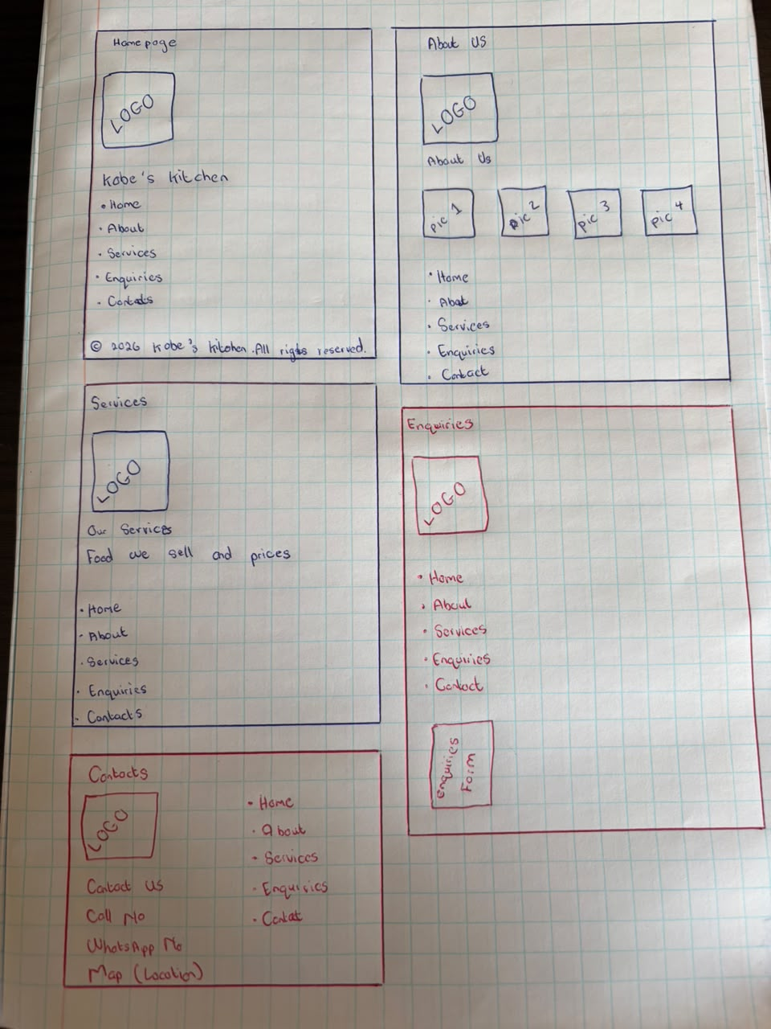
- Technical Requirements
Hosting:
- GitHub Pages
Domain:
- KobesKitchen.co.za - R99/year
Languages and Frameworks:
- HTML5 for the structure.
- CSS3 in css_assets for styling.
- JavaScript for form validation.
- GitHub for version control.

- Timeline and Milestones
- Week 3 (July) - Business Overview + Goals + Wireframes
- Week 1 (Aug) - Building HTML pages, index, about, services, inquiries, and contacts
- Week 2 (Aug) - Adding final touches, final testing, budget, and submission

- Budget
- Domain Name - R200/year
- Hosting GitHub - R0 – R500/year
- Development (Student Project) - R3400 (40 hours times R85/hr)
- Maintenance - R500/month for updates
- Total first year cost = R4600

- References
Unsplash.com for pictures
YouTube video: https://youtu.be/FQdaUv95mR8?si=DHEyhVBorD8Cj_Fa

